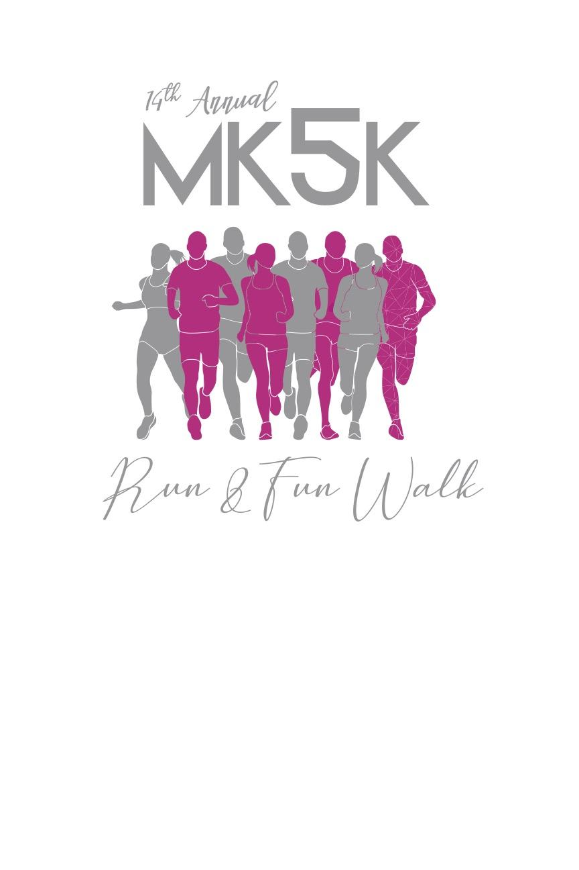
MK 5K Run & Family Fun Walk
Wednesday, August 2, 2023
Registration Form
Check-In/On-Site Registration: 6:00 p.m.
Race Begins: 6:30 p.m., Nobles County Fairgrounds, Worthington, MN
First Name ____________________________ Last Name ___________________________________________ Date of Birth (Month/Date/Year) _____________________________
Address___________________________________________________________________________________ City_______________________________________________State__________Zip_______________________ Phone___________________________________Email_____________________________________________ _____ 2 mile Fun Walk or _____5K Run
Sponsorship Team:__________________________________________________________________________
Entry Donation:
___ Pre-registration $30
___ Day of walk/run (August 3rd) $40
Please make checks payable to: Southwest Crisis Center

T-shirt Size:
Kid Sizes ___Small ___Medium ___Large
Adult Sizes ___Small ___Medium ___Large ___XLarge ___XXLarge ___XXXLarge
WAIVER: I hereby release the race director, co-directors, Nobles County Fair Board, and all other sponsors and/or individuals from responsibility from any injuries or damages I may suffer as a result of my participation in this event. I have read the entry information provided and certify my compliance by my signature below. I also understand the entry fees I pay are NONREFUNDABLE. I attest and certify that I have full knowledge of the risks involved with this event and am physically fit and sufficiently trained to participate in this event.
Signature______________________________________________________________________________________________________________ (by parent or guardian if participant is under 18 years old)
*****************************************************************************
Race Details: The Nobles County Fairgrounds is located one block north of Oxford Street on Stower Drive in Worthington. The MK5K Run & Family Fun Walk will begin and end on the north end of Nobles County Fairgrounds near the grandstand. Check-In/On-Site Registration begins at 6:00 p.m. All participants must check-in at the MK5K registration table prior to the start of the event.

